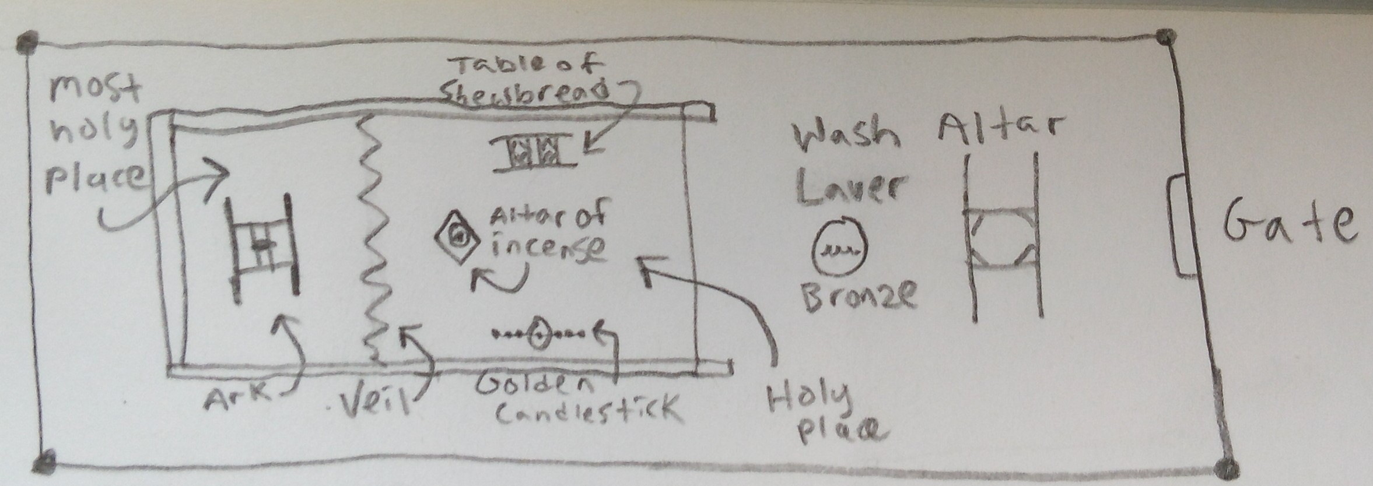
Hebrews 10:22
Let us draw near with a true heart in full assurance of faith, having our hearts sprinkled from an evil conscience, and our bodies washed with pure water.

- Read Hebrews 10:19-22 (one sentence)
- Exodus 25-31, 35-50 – Instructions for building & using the tabernacle.
- Hebrews 11:4, Genesis 4:4 – First sacrifices in scripture.
- John 14:6 – The new and living way (Hebrews 10:20).
- Exodus 26:33 - The vail in the tabernacle separated the holy place from the most holy place (AKA Holy of holies).
- Exodus 29:4 – Part of the ceremony of hallowing the priests was to wash them with water.
- Leviticus 21 – Rules for priests, definition of “high priest” (v10)

Hebrews 10:22
G228  true | ἀληθινός alēthinós, al-ay-thee-nos'; from G227; truthful:—true.
G4136  assurance | πληροφορία plērophoría, play-rof-or-ee'-ah; from G4135; entire confidence:—(full) assurance.

“sprinkled”
After the 10 commandments & law were given to Moses & the children of Israel (Ex. 20-23) & the people agreed with the LORD (Ex. 24:3). Moses built an altar (Ex. 24:4). He sent young men of the children of Israel which offered burnt offerings & peace offerings (Ex. 24:5). Half of the blood was sprinkled on the altar (Ex. 24:6). Moses then read the book of the covenant and the audience of the people agreed (Ex. 24:7). Then, Moses took the other half of the blood in the basons and sprinkled it on the people (Ex. 24:8).

Read Hebrews 10:1-18
Notes on back

Leviticus 16 – Day of atonement / Yom Kippur / holy convocation (Lev. 23:27)

Summary:
Once per year on the tenth day of the seventh month (Tishrei) the high priest would offer sacrifices for himself and the children of Israel.

10 Tishrei corresponds roughly to September-October

Leviticus 16:31
It was also a sabbath rest day and everyone was required to “afflict your souls” (fast). The penalty for disobeying was death. (Lev. 23:28-30).

Isaiah 58:3, 58:5, 58:10 (afflicting soul ~ fasting)

